**Insert School Logo**

**Semester Two**

**Examination 2020**

**Question/Answer booklet**

**MATHEMATICS**

**METHODS UNIT 1 and 2**

**Section One:**

**Calculator–free**

|  |
| --- |
| Student Name: _____________________________________ |
| Teacher’s Name: _____________________________________ |
|  |

**Time allowed for this section**

Reading time before commencing work: five minutes

Working time for paper: fifty minutes

**Material required/recommended for this section**

**To be provided by the supervisor**

This Question/Answer booklet

Formula Sheet

**To be provided by the candidate**

Standard items: pens (blue/black preferred), pencils (including coloured), sharpener, correction tape/fluid, erasers, ruler, highlighters

Special Items: nil

**Important note to candidates**

No other items may be taken into the examination room. It is **your** responsibility to ensure that you do not have any unauthorised notes or other items of a non–personal nature in the examination room. If you have any unauthorised material with you, hand it to the supervisor **before** reading any further.

**Structure of this paper**

|  |  |  |  |  |  |
| --- | --- | --- | --- | --- | --- |
|  | Number of questions available | Number of questions to be attempted | Working time (minutes) | Marks available | Percentage of exam |
| **Section One**  **Calculator—free** | **7** | **7** | **50** | **50** | **35** |
| Section Two  Calculator—assumed | 13 | 13 | 100 | 100 | 65 |
|  | | | | 150 | 100 |

**Instructions to candidates**

1. The rules for the conduct of Western Australian external examinations are detailed in the

*Year 12 Information Handbook 2020.* Sitting this examination implies that you agree to abide by these rules.

1. Answer the questions according to the following instructions.

**Show all your working clearly.** Your working should be in sufficient detail to allow your

answers to be checked readily and for marks to be awarded for reasoning. Incorrect answers given without supporting reasoning cannot be allocated any marks. For any question or part question worth more than two marks, valid working or justification is required to receive full marks. If you repeat an answer to any question, ensure that you cancel the answer you do not wish to have marked.

It is recommended that you **do not use pencil**, except in diagrams.

1. You must be careful to confine your responses to the specific questions asked and to follow any instructions that are specific to a particular question.
2. Spare pages are included at the end of this booklet. They can be used for planning your responses and/or as additional space if required to continue an answer.

* Planning: If you use the spare pages for planning, indicate this clearly at the top of the page.
* Continuing an answer: If you need to use the space to continue an answer, indicate in the original answer space where the answer is continued, i.e. give the page number. Fill in the number of the question that you are continuing to answer at the top of the page.

1. The Formula Sheet is **not** handed in with your Question/Answer Booklet.

# Section One: Calculator–free 35% (50 marks)

This section has **seven (7)** questions. Attempt **all** questions. Write your answers in the spaces provided.

Spare pages are included at the end of this booklet. They can be used for planning your responses and/or as additional space if required to continue an answer.

* Planning: If you use the spare pages for planning, indicate this clearly at the top of the page.
* Continuing an answer: If you need to use the space to continue an answer, indicate in the original answer space where the answer is continued, i.e. give the page number. Fill in the number of the question(s) that you are continuing to answer at the top of the page.

Working time: 50 minutes

**Question 1 (8 marks)**

A function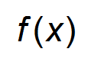is given such that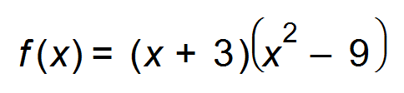.

(a) Find all the solutions of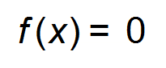. (2 marks)

(b) Use Calculus methods to find the coordinates of the turning points, and state their nature.

(5 marks)

(c) State the equation of the function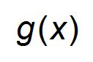given thatis equivalent to the function translated one unit to the left. (Do not simplify.) (1 mark)

**Question 2 (5 marks)**

The graph below shows the velocity (m/s),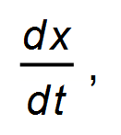as a function of time.

Initially the particle is at the origin.

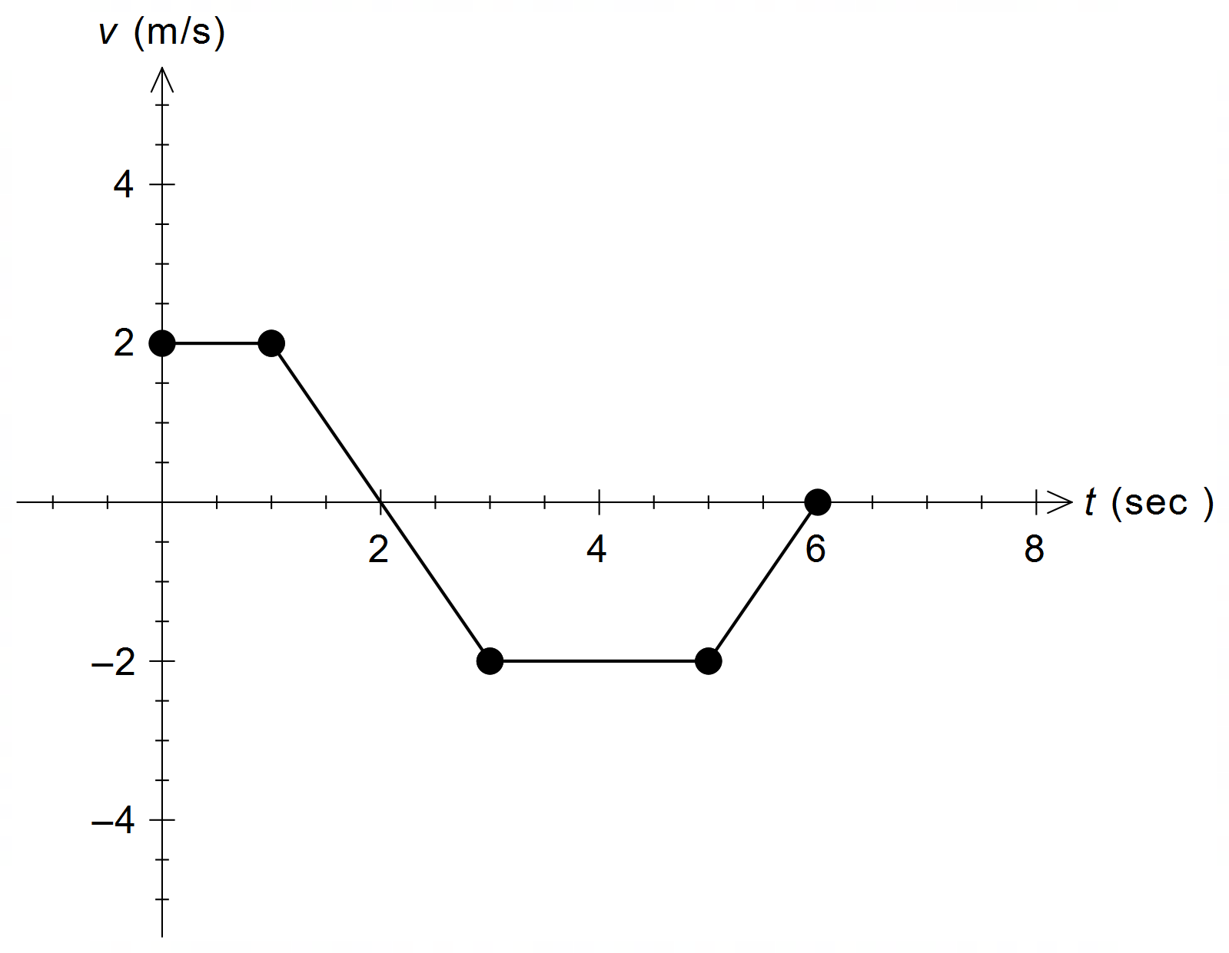

(a) When is the rate of change of the displacement of the particle constant? (2 marks)

(b) At what time is the displacement, *x*, from the origin a maximum? (1 mark)

(c) On the axes below draw a sketch of the acceleration,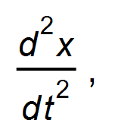for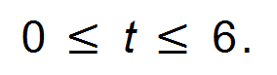 (2 marks)

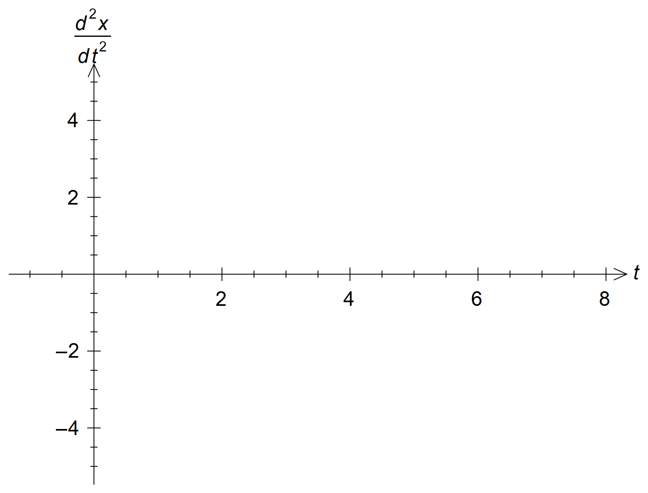

**Question 3 (8 marks)**

(a) Solve for *x*

(i) 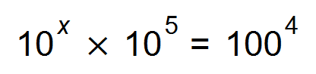 (1 mark)

(ii) 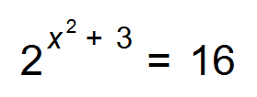 (2 marks)

(b) The product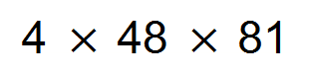is divisible by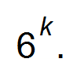

Determine the largest possible integer value of *k*. (3 marks)

(c) Simplify leaving your solution in scientific notation:

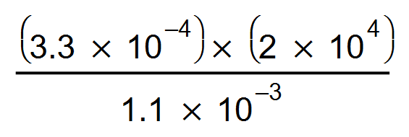 (2 marks)

**Question 4 (6 marks)**

Consider the graphs of the functions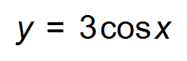 and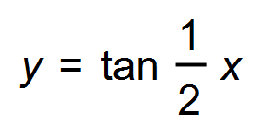 for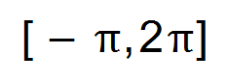below.

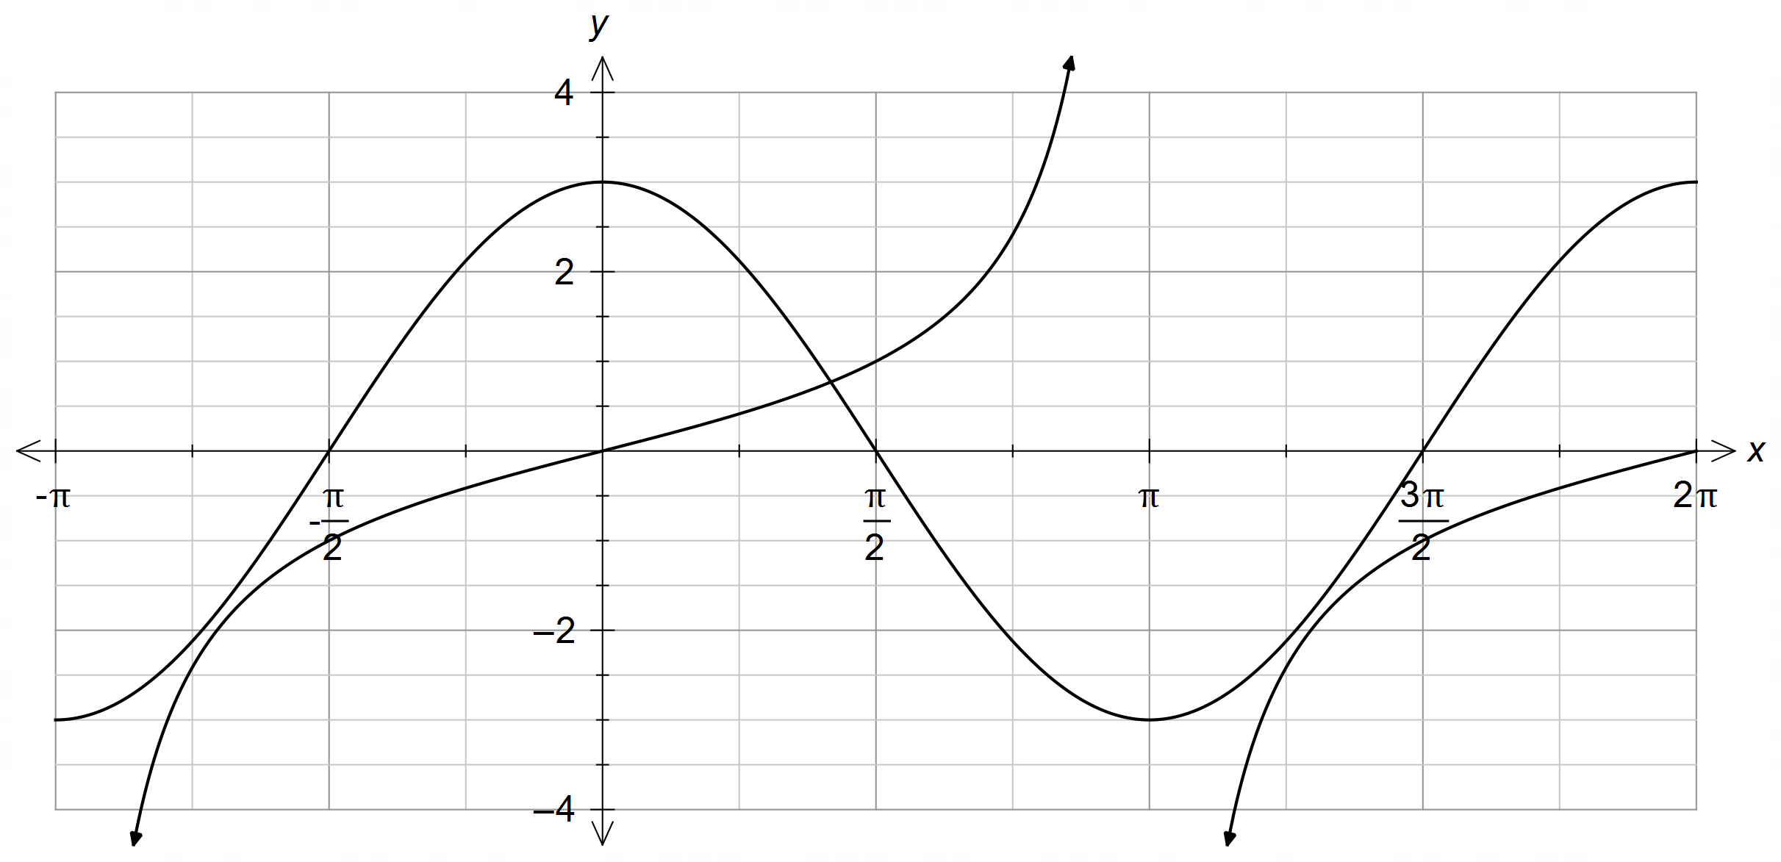

(a) State the period of the function. (1 mark)

(b) State the co-ordinates of the turning point(s) of. (2 marks)

(c) State the equation of an asymptote. (1 mark)

(d) For which values of *x* do both functions increase, as *x* increases? (2 marks)

**Question 5 (4 marks)**

The numbers 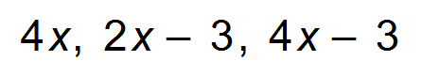are three consecutive terms in an arithmetic sequence.

(a) What is the value of *x*? (2 marks)

(b) State the recursive definition for this sequence. (2 marks)

**Question 6 (9 marks)**

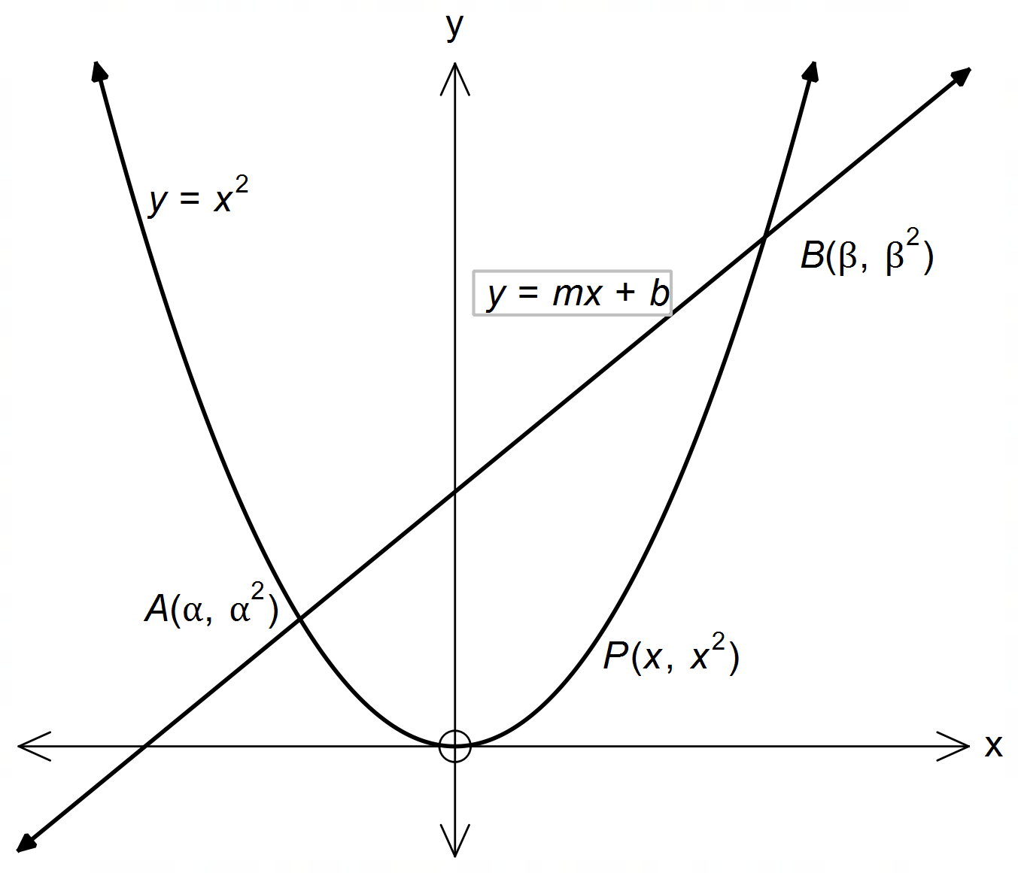The parabola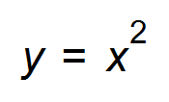intersects with the line AB at the points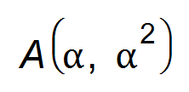and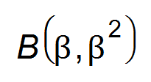as shown in the diagram.

(a) Show clearly that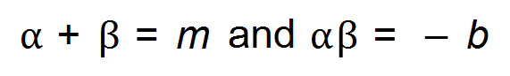. (4 marks)

(Question 6 continued)

(b) Given that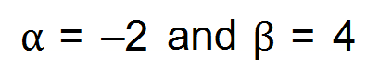find

(i) the equation of the line AB. (1 mark)

(ii) The length of the line segment from A to B. (2 marks)

(iii) P is a point on the parabola such that the midpoint of the line segment

AP is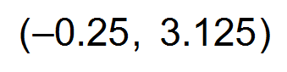. Determine the co-ordinates of the point P. (2 marks)

**Question 7 (10 marks)**

(a) Complete the following contingency table. (2 marks)

|  |  |  |  |
| --- | --- | --- | --- |
|  | Location A | Location B | Totals |
| Buses left late | 15 |  | 55 |
| Buses left on time |  | 20 |  |
| Totals | 40 |  | 100 |

Refer to the above table.

(b) (i) Identify the events. (1 mark)

(ii) Determine whether these events are dependent or independent. (3 marks)

(iii) If the bus leaves location A, determine the probability that it is on time. (1 mark)

(Question 7 continued.)

Refer to the table and information on the previous page.

(c) (i) Complete the Venn Diagram below. (2 marks)

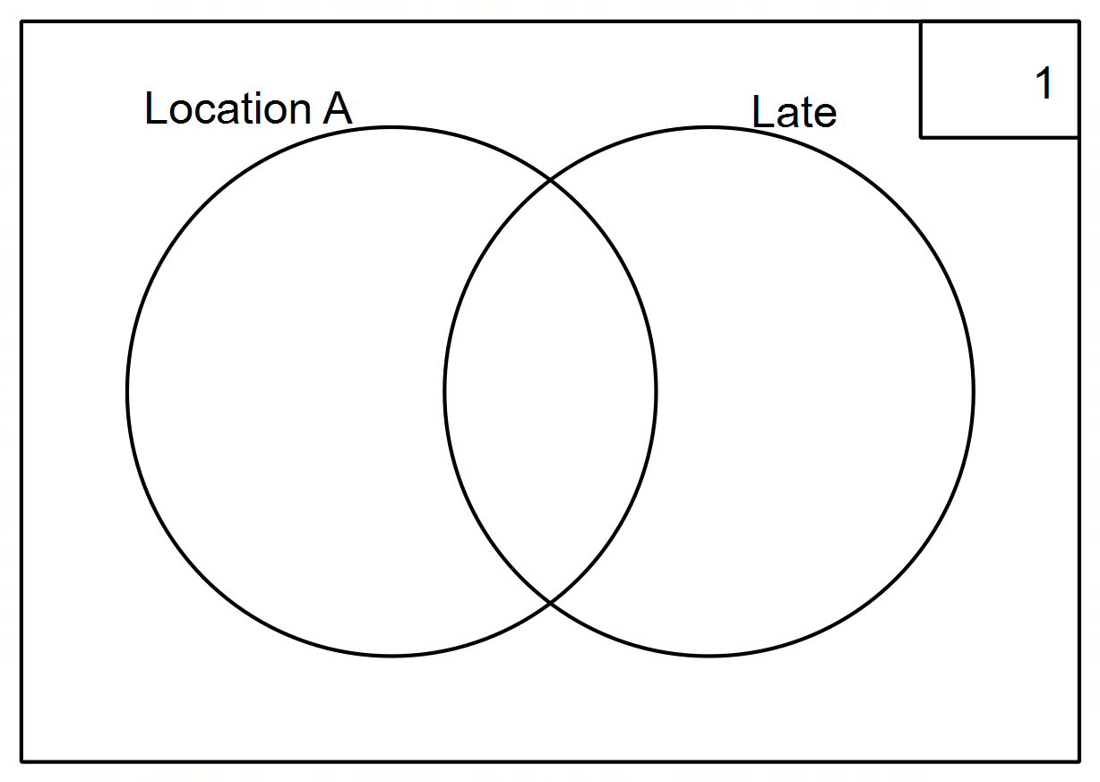

(ii) Shade in the region on the Venn diagram to show that the bus left

from Location B and is on time. (1 mark)

**End of Questions**

**Additional working space**

Question number(s): ……………………